**Answer to the Question No.01:**

#include<stdio.h>

int Count(int a,int b);

int main()

{

int x,y,counter=0;

scanf("%d%d",&x,&y);

counter = Count(x,y);

printf("\ndivisible by 5 and 7 between the range of %d-%d: %d\n",x,y,counter);

}

int Count(int a,int b)

{

int i,c=0;

for(i=a; i<=b; i++)

{

if(i%5==0 && i%7==0)

{

c+=1;

}

}

return c;

}

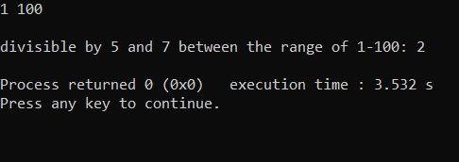

**Answer to the Question No.02:**

#include<stdio.h>

#include<stdlib.h>

#include<time.h>

int Check(int r1,int r2,int n );

int main()

{

int n;

printf("INPUT AN INTEGER NUMBER BETWEEN 1 AND 6: ");

scanf("%d",&n);

srand(time(0));

int r1=1+(rand()%6);

int r3=1+(rand()%6);

printf("1st random number is %d\n",r1);

printf("2nd random number is %d\n",r3);

Check(r1,r3,n);

}

int Check(int r1,int r3,int n)

{

if(n==r1 && n==r3)

{

printf("\n YOU WIN!!!\n");

}

else

{

printf("\n YOU LOSE!!!\n");

}

return 0;

}

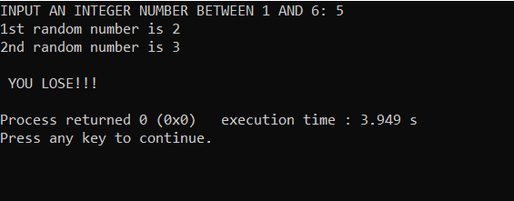

**Answer to the Question No.03:**

#include<stdio.h>

int sum(int num)

{

if(num)

return(num+sum(num-1));

else

return 0;

}

int main()

{

int count;

scanf("%d",&count);

printf("Sum of 1st %d natural number is %d\n",count,sum(count));

}

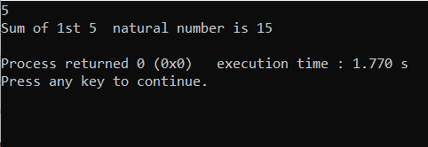

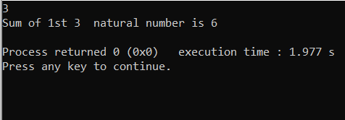

**Answer to the Question No.04:**

#include<stdio.h>

float circle(float);

float another(float);

int main()

{

float r,result,l;

printf("enter the radious:");

scanf("%f",&r);

result=circle(r);

printf("the area is %f",result);

another(result);

return 0;

}

float circle(float x)

{

float a,y;

y=3.14;

a=y*x*x;

return a;

}

float another(float a)

{

if(a>25){printf("\n%f is greater than 25",a);

}

else{

printf("\n%f is less than 25",a);

}

}

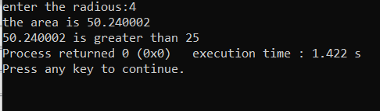

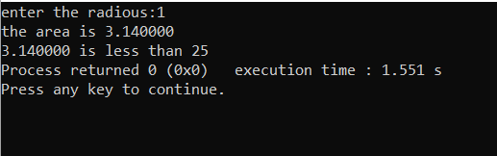

**Answer to the Question No.05:**

#include<stdio.h>

int n(int a);

int main()

{

int x;

scanf("%d",&x);

n(x);

return 0;

}

int n(int a)

{

if(a==0)

return 0;

else

printf("\nHello World\n"); n(a-1);

}

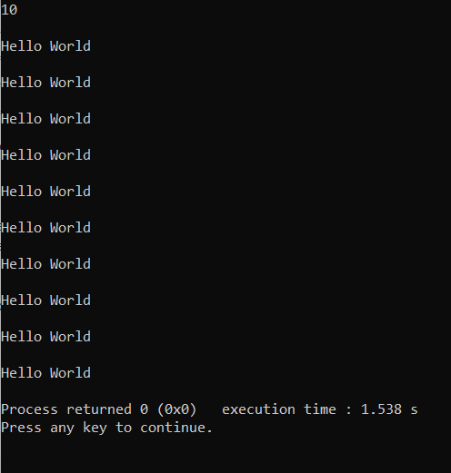

**Answer to the Question No.06:**

#include <stdio.h>

int P(int num, int i);

int main()

{

int num, check;

printf("Enter a number: ");

scanf("%d", &num);

check = P(num, num / 2);

if (check == 1)

{

printf("%d is a prime number\n", num);

}

else

{

printf("%d is not a prime number\n", num);

}

return 0;

}

int P(int num, int i)

{

if (i == 1)

{

return 1;

}

{

if (num % i == 0)

{

return 0;

}

else

{

return P(num, i - 1);

}

}

}

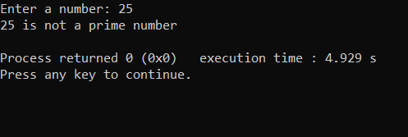

**Answer to the Question No.07:**

#include<stdio.h>

int integerPower(int base, int exponent)

{

int r=1;

while(exponent!=0)

{

r = r * base;

exponent--;

}

return r;

}

int main()

{

int a,b;

printf("Input base: ");

scanf("%d",&a);

printf("Input exponent: ");

scanf("%d",&b);

if(b>0)

{

printf("%d",integerPower(a,b));

}

else

printf("ERROR!!");

return 0;

}

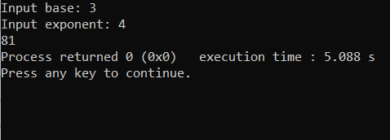

**Answer to the Question No.08:**

#include<stdio.h>

void num(int n)

{

if (n< 0)

{

n *= -1;

printf("- ");

}

if (n > 10)

{

num(n/ 10);

printf(" ");

}

printf("%d", n % 10);

}

int main()

{

int a;

scanf("%d",&a);

num(a);

return 0;

}

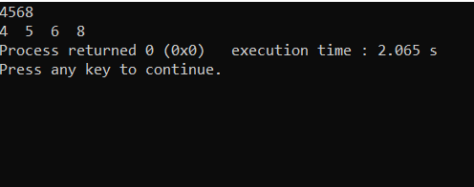

**Answer to the Question No.09:**

#include <stdio.h>

int gcd(int num1, int num2)

{

if(num1%num2 == 0)

return num2;

else

return gcd(num2,num1%num2);

}

int main()

{

int num1, num2;

printf("Enter your number = ");

scanf("%d" ,&num1);

printf("Enter your number = ");

scanf("%d" ,&num2);

printf("GCD = %d" ,gcd(num1,num2));

}

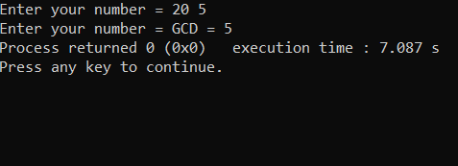

**Answer to the Question No.10:**

#include<stdio.h>

int gcd(int n1, int n2)

{

if(n2==0)

return n1;

return gcd(n2,n1%n2);

}

int lcm(int n1, int n2)

{

return (n1*n2)/gcd(n1,n2);

}

int main()

{

int n1,n2;

printf("Enter the Two Number:\n");

scanf("%d%d",&n1,&n2);

printf("Lcm of Given Number is:%d",lcm(n1,n2));

}

